Physics lab report essentials

Structure of the Report:
Title: Make sure that your file name includes information about you, your lab partner and the title of your experiment, e.g.
“The Photoelectric Effect by Ania Harlick and Young June Kim.pdf”
Pages: As a rough guideline, your report should be around 2-3 pages of text plus figures and tables for a 1 weight lab, and around 4-6 pages of text plus figures and tables for a 2 weight lab.

Structure:
- Introduction
• Statement of the experimental objective
• Short theoretical introduction
- Procedure:
• Description of experimental set-up, including diagrams or photos if
available
• List of equipment with a reading error or resolution
• Description of experimental procedure and measurement technique
- Data
• Direct measurements (raw data), presented in a table
• Uncertainties of direct measurements
- Analysis
• Sources of uncertainties
• Analysis of measured data
• Figures and diagrams, including error bars
• Uncertainty propagation calculations for indirect measurements
• Curve fitting and assessment of quality of fit
- Conclusion
• Presentation of results and comparison with expected results
• Discussion of results, suggestions for improving quality of results
Example: https://q.utoronto.ca/courses/411783/files/38572943?module_item_id=6930484

Summaries of Concepts:
Commonly Used Uncertainty Propagation Formulae:
https://q.utoronto.ca/courses/411783/files/38572938?module_item_id=6930490
- Independent variables x, y, … with uncertainties Δx, Δy, …, uncertainty of x=f(x,y,…) is:
$$x^{2}=(\frac{∂f}{∂x}x)^{2}+=(\frac{∂f}{∂y}y)^{2}+…$$
NOTE: if any terms on RHS are <10% of largest term, can ignore
- 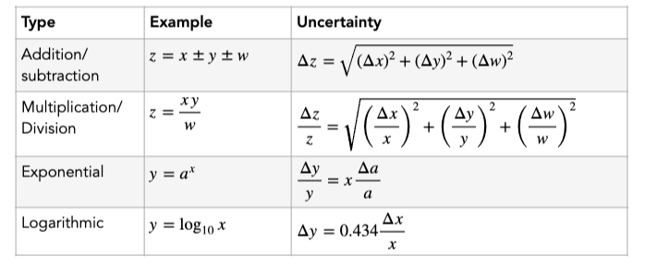
The above equations apply if variables are independent -> otherwise, look at covariance
Uncertainties in Linear Fit:
https://q.utoronto.ca/courses/411783/files/38572938?module_item_id=6930490
If N measurements result in N pairs of x_i and y_i, we expect that y is the linear function of x given by y=mx+b, where
$$∆=N\sum{{(x}_{i})^{2}-(\sum{x_{i})^{2} ;}}$$
$$m=\frac{N\sum_{i=1}^{N}{x_{i}y_{i}-\sum_{i=1}^{N}{x_{i}\sum_{i=1}^{N}{y_{i}}}}}{∆};b=\overline{y}-m\overline{x}=\frac{\sum_{i=1}^{N}{y_{i}-m\sum_{i=1}^{N}{x_{i}}}}{N}$$
Linear fit of y=mx+b given by m and b, with slope = m+=s_m, y-intercept =b+-s_b, where s_m and s_b are:
If 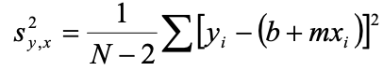 is the variance of y(x), the standard deviation s_m of estimated slope is a square root of 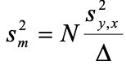, and standard deviation s_b of y-intercept is square root of 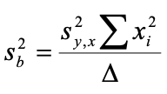.
The coefficient of determination R^2 is:
$$R^{2}=1-\frac{\left(N-2\right)s_{y,x}^{2}}{\sum{(y_{i}-\overline{y})^{2}}}=1-\frac{\left(N-2\right)s_{y,x}^{2}}{\sum{(y_{i}-\frac{\sum{y_{i}}}{N})^{2}}}$$
Brief Notes on Linear Fits:
https://q.utoronto.ca/courses/411783/files/38572935?module_item_id=6930492
Each measured/calculated value must be represented with uncertainty.
An xy-diagram with data points and function of best fit y(x) must show error bars for both x and y-values. Error bars for y-values are either random (statistical) or reading, whichever is greater. Error bars for x-value are reading uncertainty. Should be in caption.
Finding line of best fit by drawing trend line, getting R^2 is NOT enough for uncertainty. Excel’s least squares linear fit can be used if data points shown with error bars and uncertainty for both slope and y-intercept shown/in caption.
- Use LINEST in Excel
  - Does not account for uncertainties in x-values because can’t account for reading errors in both dimensions
  - To be accurate, compare reading error in y and variance of y-values s(y). Biggest between two = final uncertainty
- Can use MATLAB to fit by entering error bars for both dimensions along with polynomial power and zero estimate of slope and y-intercept
  - Zero estimate: use Excel
  - MATLAB’s linear fit returns: slope and y-int with uncertainties, chi-squared criterion of goodness of ti (close to number of degrees of freedom)
Graph of residuals vs. variable values (distribution of residuals about zero) justifies correctness of choice of fitting function)-> e,g. correct choice of power of polynomial
Can use own Python code to get chi-squared and goodness of fit with least squares technique
- Present as best-fit line function with parameters + units and uncertainty, and line of best fit on set of data points with error bars
- Description of uncertainties in parameters and error bars is required, can use equations from the equations in this document
Example with code:
https://colab.research.google.com/drive/1KOGlwBgyqBYVW-MSrh8RjVIMu6O_9ZNq?usp=sharing

More in-depth proofs:
Error Analysis for 2nd Year Experiments:
https://q.utoronto.ca/courses/411783/files/38572939?module_item_id=6930487
Experimental: “difference between the observed value and the true value.
Uncertainties (errors) can be separated into two categories: random and systematic.
Random errors fluctuate from one measurement to another (poor instrument sensitivity, random noise, random external disturbances, and statistical fluctuations)
Systematic errors shift measurements in a systematic way (built intoinstruments, minimized by instrument)
Experimental precision means the degree of exactness of the experiment or how well the result has been obtained. Does not make reference to the true value; it is just a quality attribute. Precision depends on how well random errors are reduced.
Accuracy refers to correctness and means how close the result is to the true value. Depends on how well the systematic errors are compensated.
The Gauss function can be written and interpreted as a probability density if we arrange itto satisfy the normalization condition:
$N\left(x\right)=Ae^{-\frac{(x-\overline{x})^{2}}{2σ^{2}}}$, and $\int_{-∞}^{∞}{P\left(x\right)dx=1=Nσ\sqrt{2π}}$
If we measured x=x_a+σ_a and x= x_b+σ_b, and x_a,x_b are mean vals and σ_a, σ_b are standard errors, then probability of getting x_b is around
$$P_{x}(x_{B})≈\frac{1}{σ_{B}}e^{\frac{-(x_{B}-X)^{2}}{2σ_{B}^{2}}}$$
With xa showing similar results. Therefore, the probability of grinding both a and b is the result of probabilities, giving:
$$P_{x}\left(x_{A},x_{B}\right)=P_{x}\left(x_{A}\right)P_{x}\left(x_{B}\right)≈\frac{1}{{σ_{A}σ}_{B}}e^{\frac{-()^{2}}{2}}$$

The exponent here is called the chi-squared (χ^2), where
$$χ^{2}=(\frac{x_{A}-X}{σ_{A}})^{2}+(\frac{x_{B}-X}{σ_{B}})^{2}$$
The principle of likelihood states that our best estimate for the unknown true value X is that value for which the actual data x_a and x_b are most likely to occur. According to this, when reaching the best estimated value, the overall probability has to be a maximum, or the value of chi-squared has to be a minimum. This method of finding the best estimate is often called the method of least squares.
To find X, look for the min of $χ^{2}$, where we see the best estimate for X is:
$$X=\frac{\frac{x_{A}}{σ_{A}^{2}}+\frac{x_{B}}{σ_{B}^{2}}}{\frac{1}{σ_{A}^{2}}+\frac{1}{σ_{B}^{2}}}$$
We can define the weights of x_a and x_b to be $w_{A}=\frac{1}{σ_{A}^{2}}$, $w_{B}=\frac{1}{σ_{B}^{2}}$, such that the weighted averages of x_a and x_b are:
$$x_{wav}=\frac{w_{A}x_{A}+w_{B}x_{B}}{w_{A}+w_{B}}$$
Which is also the best estimate for X. If we see that $σ_{A}=σ_{B}$, this just turns to the normal equation for average. We can generalize for any number of measurements of x, where if i=1,2,…, N, then
$x_{wav}=\frac{\sum{w_{i}x_{i}}}{\sum{w_{i}}}$, where $w_{i}= \frac{1}{σ_{i}^{2}}$.
The weighted average is a function of the measured values x_i. Therefore, the uncertainty in the weighted average can be calculated using the error propagation expressions (see this section).
In most experiments performed this year, we’ll determine one physical quantity y (the dependent variable) as a function of some other quantity x (the independent variable):
- Linear regression model: If the two variables are clearly related by a linear relationship such as: y(x) = a + bx, we have to consider the linear regression method to determine the most probable values of parameters a and b. Linear regression is a method of least squares.

For any x_i, if we knew a and b we could get the true y_i=a+bx_i. Measured y_i, though, usually follow Gauss distribution, so
$$P_{a,b}\left(y_{i}\right)≈\frac{1}{σ_{y}}e^{\frac{-(y_{i}-a-bx_{i})^{2}}{2σ_{y}^{2}}}$$
Here, the probability of getting y_1, y_2, … y_N is
$P_{a,b}\left(y_{1},…y_{N}\right)=P_{a,b}\left(y_{1}\right)…P_{a,b}\left(y_{N}\right)≈\frac{1}{σ_{y}^{N}}e^{\frac{-()^{2}}{2}}$(1)
where c$χ^{2}=\sum_{i=1}^{N}{(c)^{2}}$
The principle of maximum likelihood requires a maximum probability or a minimum chisquared. Setting χ^2 to minimum means:
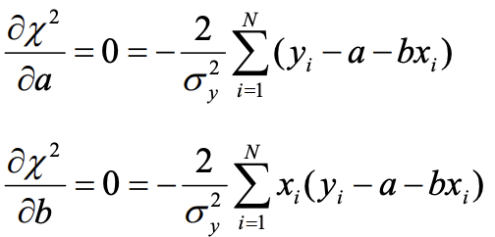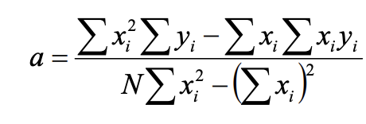, 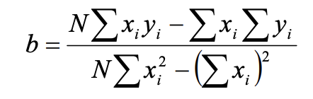
Now, with a and b, the straight line y = a + bx is called least squares fit to the data or the line of regression of y on x.
Uncertainties of y_i are normally distribution about y_i,true=a+bx_i, meaning the deviations (y_i-y_i,true)=(y_i-a-bx_i) are also normal, but about zero. Distribution of deviations have same width σ_y as measurements distribution, suggesting
${{}_{y}}^{2}=\sum_{i=1}^{N}{\frac{(y_{i}-a-bx_{i})^{2}}{N}}$ (2)
However, we need uncertainties in calculated coeffs a and b, therefore, assuming a=a(y_i) and b=b(y_i) and y_i=f(x_i), then
$σ_{a}^{2}=\frac{1}{∆}\sum{\frac{x_{i}^{2}}{σ_{i}^{2}}}$ and $σ_{b}^{2}=\frac{1}{∆}\sum{\frac{x_{i}^{2}}{σ_{i}^{2}}}$
Where
$$∆=\sum{\frac{1}{σ_{i}^{2}}\sum{\frac{x_{i}^{2}}{σ_{i}^{2}}}}-(\sum{\frac{x_{i}^{2}}{σ_{i}^{2}}} )^{2}$$
When analyzing experimental data, we have to take into account a parameter called number of degrees of freedom, which is the number of data points (N) minus the number of parameters (m), calculated from the fit. Therefore, (2) can be turned to
$${{}_{y}}^{2}=\sum_{i=1}^{N}{\frac{{(y}_{i}-a-bx_{i})^{2}}{N-2}}$$
NOTE: for any function linear in parameters, method of least squares can be extended to any number of terms as a polynomial:
$$y\left(x\right)=\sum_{k=1}^{m}{a_{k}x^{k-1}}.$$
This can become tedious, because m x m determinants have to be solved.

NOTE: least squares can work well with simple exp functions in the form $y=Ae^{Bx}$. E.g. $I=I_{0}e^{-μx}$ for intensity of radian. To linearize these, we just take the natural log of both sides to get ln(y)=ln(A)+Bx, where y is linear in x. now, we can have
$$z=\ln\left(y\right), z=\ln\left(A\right), b=B→ z=a+bx$$
AN: think of pendulum fitting!!
- Non-linear fits: you would have to generalize (1) to:
$$P(a_{1}, …, a_{m})≈exp⁡(-0.5\sum{{\frac{(y_{i}-y\left(x_{i}\right))}{σ_{i}^{2}}}^{2})}$$
Where if we maximize the likelidhood with respect to a_1, … a_m, $χ^{2}$ is called the goodness-of-fit parameter, where
$$χ^{2}=\sum{{\frac{(y_{i}-y\left(x_{i}\right))}{σ_{i}^{2}}}^{2})}$$
Where x_i and y_i are measured variables, $σ_{i}$ are the uncertainties in y_i and y(x_i) are vvaluesals of calculated fit function at x_i, depending on a_1, …, a_m. Must treat $χ^{2}$ as continuous function of m parameters and search m-D space for min of $χ^{2}.$

NOTE: alternative method is to find roots of m nonlinear coupled equations through approximations methods, but this is difficult and you can use computers for this.
Covariance is part of ‘leastsq’ module from scipy and a parameter $σ_{x,y}$, where if it’s not zero, it assess how errors in x and y are related. The coefficient of linear correlation is a measure of goodness of fit.
If you measured x_i and y_i N times, mean values of x and y and corresponding standard deviations, and you see that uncertainties are small, then we can expand f_i=f(x_i,y_i), i=1,2,…, N about the means of x and y:
$f_{i}=f\left(x_{i,}, y_{i}\right)≅f\left(\overline{x},\overline{y}\right)+{(x}_{i}-\overline{x})\frac{∂f}{∂x}|_{x=\overline{x}}+{(y}_{i}-\overline{y})\frac{∂f}{∂y}|_{y=\overline{y}}$ (3)
The average of all function values can be calculated as any other one-variable mean value:
$$\overline{f}=\frac{\sum_{i=1}^{N}{f_{i}}}{N}$$
We notice in (3) that partials taken at $x_{i}=\overline{x}$ and $y_{i}=\overline{y}$ for all i, meaning the second and third terms become zero when adding, leaving us with
$\overline{f}=f\left(\overline{x},\overline{y}\right)$ (4)
Therefore, te mean of function f is the value calculated at the averages of x and y. We can extrapolate that
$$σ_{f}^{2}=\frac{\sum_{i=1}^{N}{{(f}_{i}-\overline{f})^{2}}}{N}$$
Where if we use (3) and (4), then we get
$$σ_{xy}=\frac{\sum_{i=1}^{N}{{(x}_{i}-\overline{x}){(y}_{i}-\overline{y})}}{N}$$
Called the sample covariance of x and y. When σ_xy is not zero, the errors in x and y are correlated.
The linear correlation coefficient r measures the extent to which the set (x_i, y_i) (i =1,2,...N) supports a linear relation between x and y:
$$r=\frac{σ_{xy}}{σ_{x}σ_{y}}$$
Values of r near +1 or -1 indicate strong correlation; values close to zero indicate very little or zero correlation.
The variance of the fit is defined as:
$$s^{2}=\frac{1}{N-m}\frac{\sum{{\frac{(y_{i}-f\left(x_{i}\right))}{σ_{yi}^{2}}}^{2})}}{\frac{\sum{\frac{1}{σ_{yi}^{2}}}}{N}}$$
The factor v=N-m is the number of degrees of freedom for fitting N data points with m parameters. You can relate v, $χ$, s, $σ_{yi}$ with
$$\frac{χ^{2}}{v}=\frac{s^{2}}{σ_{i}^{2}}$$
Where $σ_{i}^{2}$ is weighted average of all individual variances:
$$σ_{i}^{2}=(\frac{\sum{\frac{1}{σ_{i}^{2}}}}{N})^{-1}$$
S^2 is characteristic for both the distribution of data and the goodness of the fit. If the fitting function is a good approximation to experimental data, the estimated variance s^2 should agree well with σ^2 and the reduced chi-squared $χ_{v}^{2}=\frac{χ^{2}}{v}$ should be close to 1. A value of $χ_{v}^{2}$much larger than 1 or much less than 1 means an underestimation or overestimation of experimental uncertainties, respectively.
If the results were perfect we should have obtained a chi-square value of zero because the observed and calculated values were identical. This never happens in real lab experiments. Most times the fit is very different from experimental values. This is represented by the long tail on the graph:
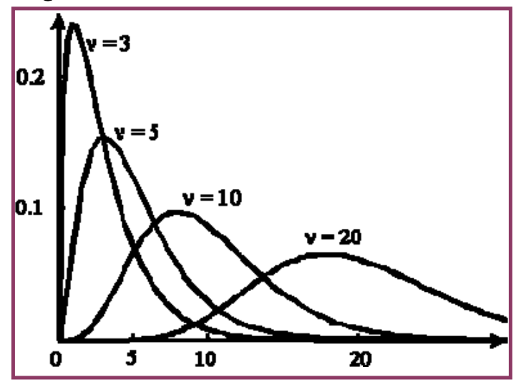
Main properties of chi-squared distribution:
- Total area under curve =1
- Mean of distribution = number of degrees of freedom
- As degrees of freedom increase, chi-square curve approaches normal distribution.
A typical example of a Poisson experiment is the statistical study of a radioactive decay: a radioactive source is placed in front of a counter (Geiger-Mueller tube) and random events are recorded. All Poisson experiments are characterized by the following properties:
- The experiment results in “success” or “failure” outcomes. Success is determined by the physical recording of a radioactive event; failure is the non-event.
- If we investigate the decay within a certain time or energy window, we can define the average number of successes (μ) that occur per window.
- Probability of a success occurrence is proportional to the size of the window.
- By reducing the size of the window to something very, very small, the success probability will be close to zero.
If μ is the mean number of successes in window and x is actual successes (Poisson random variable), the Poisson probability:
$$P\left(x;μ\right)=\frac{e^{-μ}μ^{x}}{x!}$$
The Poisson distribution is discrete, defined only at integer values of the variable, in contrast with the continuous normal (Gaussian) distribution. The variance of a Poisson distribution is equal to the mean μ. The standard deviation is given by σ= $√$μ, which is the golden rule of assessing the uncertainty in a counting experiment: it is given by the root of the average number of counts per counting interval.
For large μ, number of ‘rare events’ approaches zero, so the probability sum:
$$S_{P}\left(x_{1},x_{2} ;μ\right)=\sum_{x_{1}}^{x_{2}}{\frac{e^{-μ}μ^{x}}{x!}}$$
may be approximated by an integral of the Gaussian function.
Error Analysis in Experimental Physical Science (from 1st year):
https://faraday.physics.utoronto.ca/PVB/Harrison/ErrorAnalysis/index.html
The error in an experimentally measured quantity is never found by comparing it to some number found in a book or web page.
Normal distribution -- type of continuous probability distribution for a real-valued random variable. The most common mathematical formula used to describe them is called a Gaussian, although it was discovered 100 years before Gauss by de Moivre.
$N\left(x\right)=Ae^{-\frac{(x-\overline{x})^{2}}{2σ^{2}}}$,
A=max amp, x bar = mean/average, sigma = st. dev., where st dev^2 = variance.
$σ=\sqrt{\frac{\sum_{i=1}^{N}{{\left(x_{i}-\overline{x}\right)}^{2}}}{N-1}}$,
usually N-1 for Bessel’s correction for small sample sizes. The quantity N - 1 is called the number of degrees of freedom.
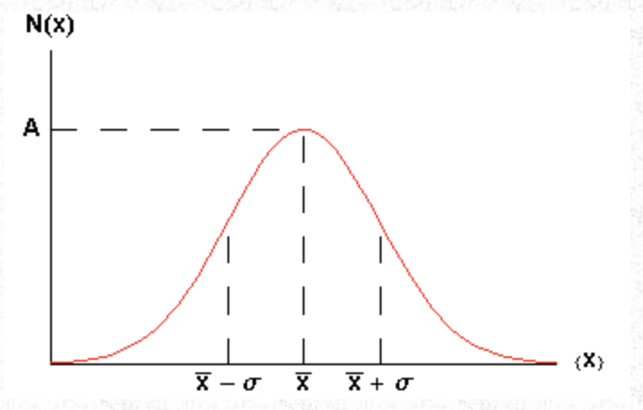
68% of the area under the curve of a Gaussian lies between the mean minus the standard deviation and the mean plus the standard deviation. Similarly, 95% of the curve is between the mean minus twice the standard deviation and the mean plus twice the standard deviation.
If we could increase the sample size to infinity, we might expect the data would perfectly match the curve. However there are problems with this:
- For data like the height data, we can not even in principle increase the sample size to infinity since there are not an infinite number of people in the world.
- For data like the radioactive decays, it would take an infinite amount of time to repeat the measurements an infinite number of times.
- C clearly the assumption of a normal distribution is only an approximation. For example, the Gaussian only approaches zero asymptotically at ± infinity. If height data is truly Gaussian we could expect to find some people with negative heights, which is clearly impossible!
Therefore, for data which are normally distributed, the true value of the mean and the standard deviation may only be found if there are an infinite number of data points.
The standard deviation is the error in each individual measurement of the sample. We can show this by $∆x_{i}=σ$. This error is often called statistical.
It can be shown that the standard deviation of this distribution of estimated standard deviations, which is the error in each value of the estimated standard deviation, is:
$∆σ_{est}=\frac{σ_{est}}{\sqrt{2\left(N-1\right)}}$.
To determine the reading error in a measurement we have to answer the question: what is the minimum and maximum values that the position could have for which we will not see any difference?
For experimental data the error in a quantity defines how many figures are significant. In simple cases errors are specified to one or at most two digits.
The fractional error is the value of the error divided by the value of the quantity: X / X. The fractional error multiplied by 100 is the percentage error. Everything is this section assumes that the error is "small" compared to the value itself, i.e. that the fractional error is much less than one.
RULE 1:
If z=x+y or z=x-y, then
$$∆z=\sqrt{∆x^{2}+∆y^{2}}$$
In words, this says that the error in the result of an addition or subtraction is the square root of the sum of the squares of the errors in the quantities being added or subtracted. This mathematical procedure, also used in Pythagoras' theorem about right triangles, is called quadrature. We do this because of linear algebra, because if x and y are the only qtts in z, then their errors X and Y are the only errors and span the space. Z is only 0 if both are zero, therefore they’re a basis. Then, using Pythagoras, we see if we want the error of any vector z, we’d have to combine X and Y in quadrature (because they’re orthogonal), therefore, QED.
RULE 2:
If z=x*y or z=x/y, then
$$\frac{∆z}{z}=\sqrt{(\frac{∆x}{x})^{2}+(\frac{∆y}{y})^{2}}$$
In this case also the errors are combined in quadrature, but this time it is the fractional errors, i.e. the error in the quantity divided by the value of the quantity, that are combined. Sometimes the fractional error is called the relative error.
RULE 3:
If z=$x^{n}$, then
$$∆z=nx^{n-1}∆x$$
or
$$\frac{∆z}{z}=n\frac{∆x}{x}$$
For the square of a quantity, X², you might reason that this is just X times X and use Rule 2. This is wrong because Rules 1 and 2 are only for when the two quantities being combined, X and Y, are independent of each other. Here there is only one measurement of one quantity.
If
$$\overline{x_{est}}=\sqrt{∆x^{2}+∆x^{2}+…+ ∆x^{2}}=\sqrt{N}∆x$$
Then
$$∆\overline{x_{est}}=\frac{∆x}{\sqrt{N}}$$
Sometimes is called the standard error of the mean.
When all measurements are systematically/collectively either too high or too low. This type of error is called a systematic error. It is an error of accuracy. Note that, as opposed to errors of precision, repeating the measurement does no good in increasing the accuracy of the measurement. To increase the accuracy of a measurement with some instrument, we can calibrate it.
For a particular experiment, usually one of the error of precision or the error of accuracy will dominate, and we ignore the smaller of the two.
Note that it is incorrect to expect each and every measurement to overlap within errors. Thus, it is always dangerous to throw out a measurement. Whatever the reason for a suspect value, the rule of thumb is that it may be thrown out provided that fact is well documented and that the measurement is repeated a number of times so we know we’re not throwing out an important piece of data indicating a new physical process.

Summary of error propagation:
